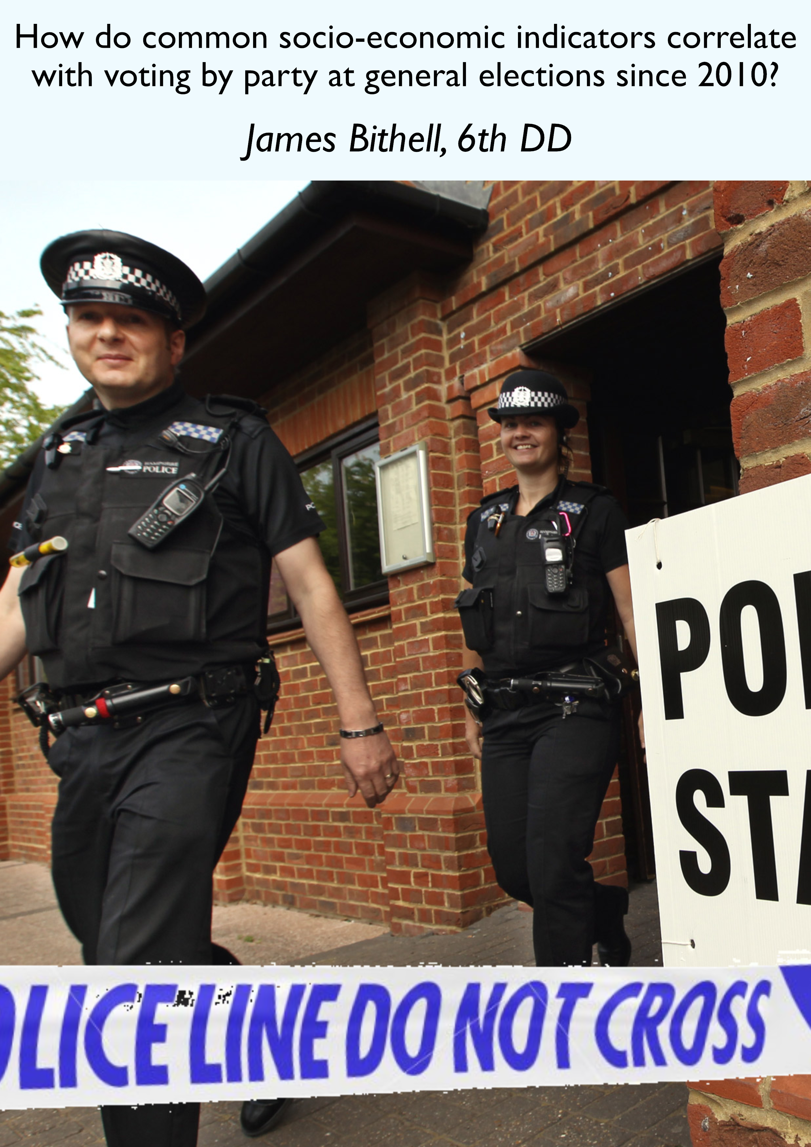

# Table of Contents

Table of Contents 2

Table of Figures 2

Introduction 2

Crime Data 7

Unemployment 16

2017 General Election update 18

# Table of Figures

Figure 1 - Map of 2015 General Election Results 3

Figure 2 - Map of 2015 General Election Results, with London in focus 4

Figure 3 - Crime data for England & Wales by Constituency 5

Figure 4 - Crime for London 6

Figure 5 - Percentage vote prediction for the 2017 General Election against total police reported crimes 7

Figure 6 - Nigel Marriott's predictions for the 2017 General Election 8

Figure 7 - Full plot of Percentage vote prediction for the 2017 General Election against total police reported crimes 8

Figure 8 - Percentage vote by party for the 2015 General Election against total police reported crimes 9

Figure 9 - Percentage vote by party for the 2015 General Election against total police reported crimes adjusted for population density 10

Figure 10 - Percentage vote by party for the 2015 General Election against total police reported crimes adjusted for population density - as full data 11

Figure 11 - England/Wales Population Density Against Party Vote Share by Constituency at the 2015 General Election 12

Figure 12 - Crime rate adjusted for population density (not just population) against vote share by constituency 13

Figure 13 - Crime rate adjusted for population density (not just population) against vote share by constituency (full data) 14

Figure 14 - Results from Facebook poll 15

Figure 15 - Unemployment against Party Voting 16

Figure 16 - Crime rate against 2015 & 2017 General Election Result 18

# Introduction

For the Westminster School 6th Form Economics End-Of-Year project I started out by creating a map of the UK, using web technologies including JavaScript, JQuery, CSS & Leaflet.js (a mapping engine) in an attempt to present and compare data for constituencies in the UK. Using data from the Office for National Statistics I was able to produce a map of constituencies[1] in the United Kingdom. Using further data from the electoral commission I was able to overlay details of the 2010 election result, and how the seat voted in the EU Referendum in 2016. Figure 1 shows a screenshot of my map.

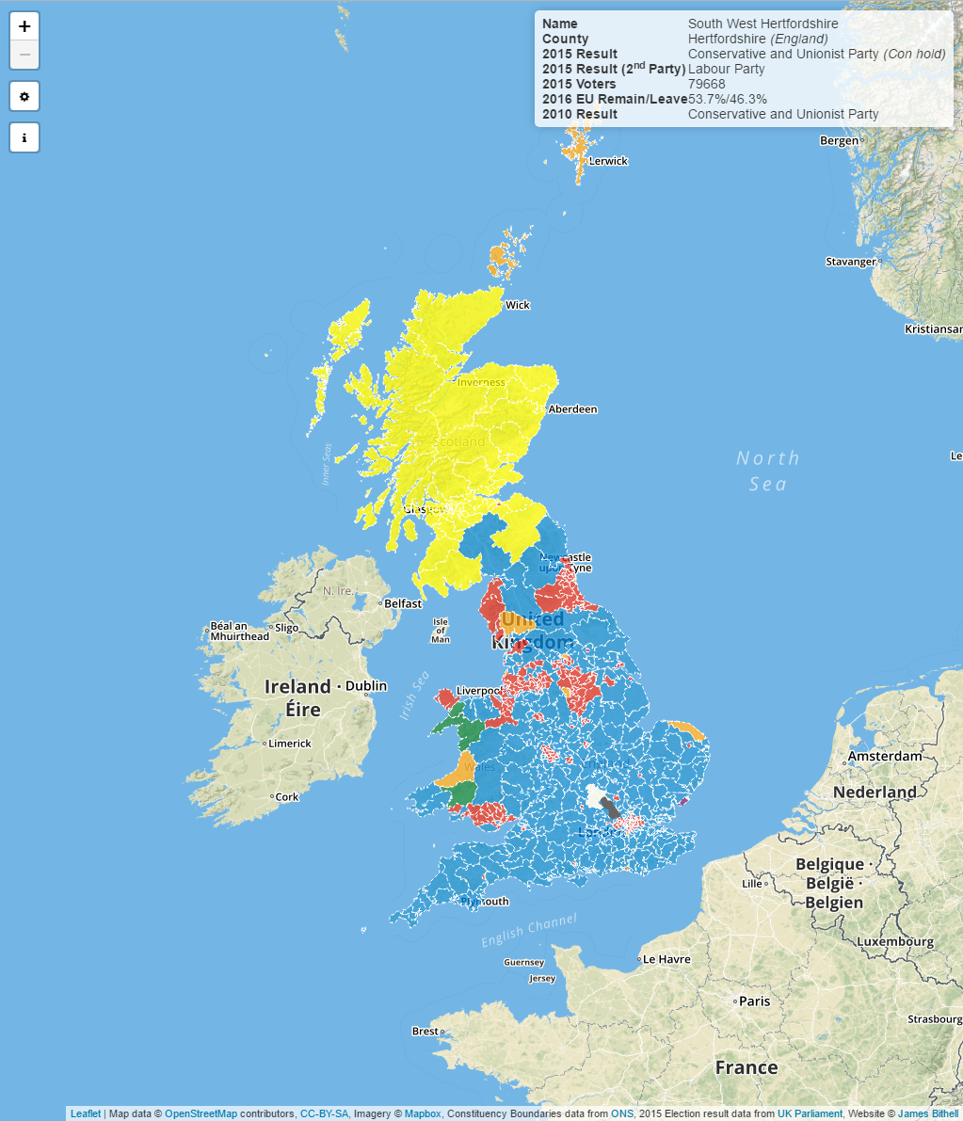

Figure 1 - Map of 2015 General Election Results

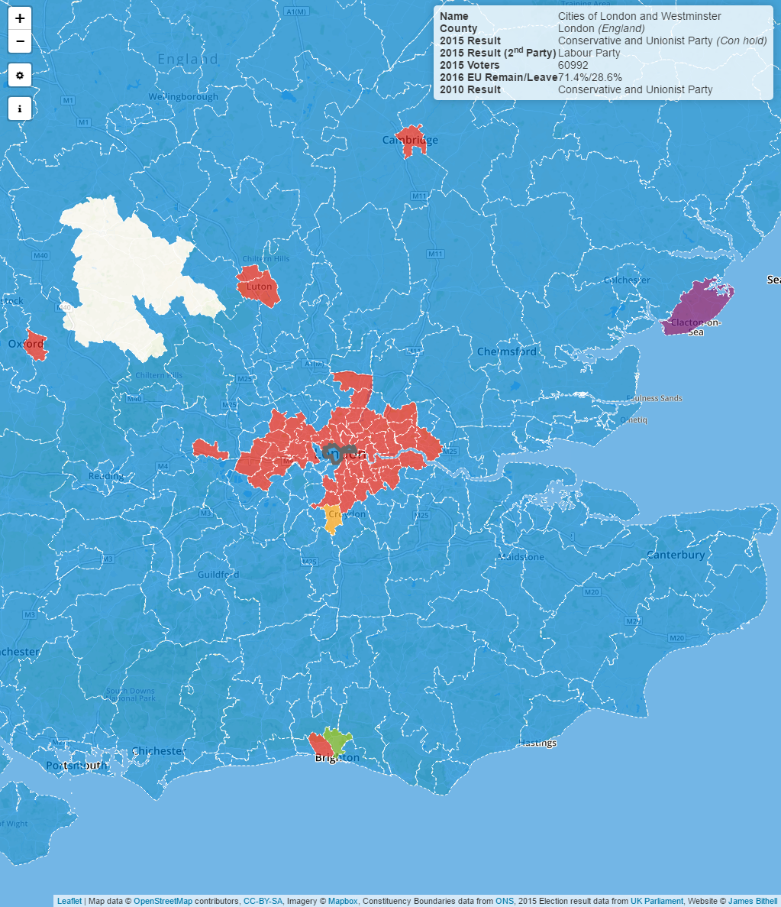

Figure 2 - Map of 2015 General Election Results, with London in focus

*The map is accessible at* <https://economicsmap.herokuapp.com/>

The challenge of this idea was mapping in a useful way further socio-economic data – crime data can easily be mapped, but it’s far trickier to compare this to party politics & economics using a map because of the visual challenge of showing two different datasets in order to present a trend – graphs are the ideal for this kind of comparison and analysis, so the project morphed into understanding the relationship between voting patterns and key socioeconomic indicators – but using graphs to present and explore the data.

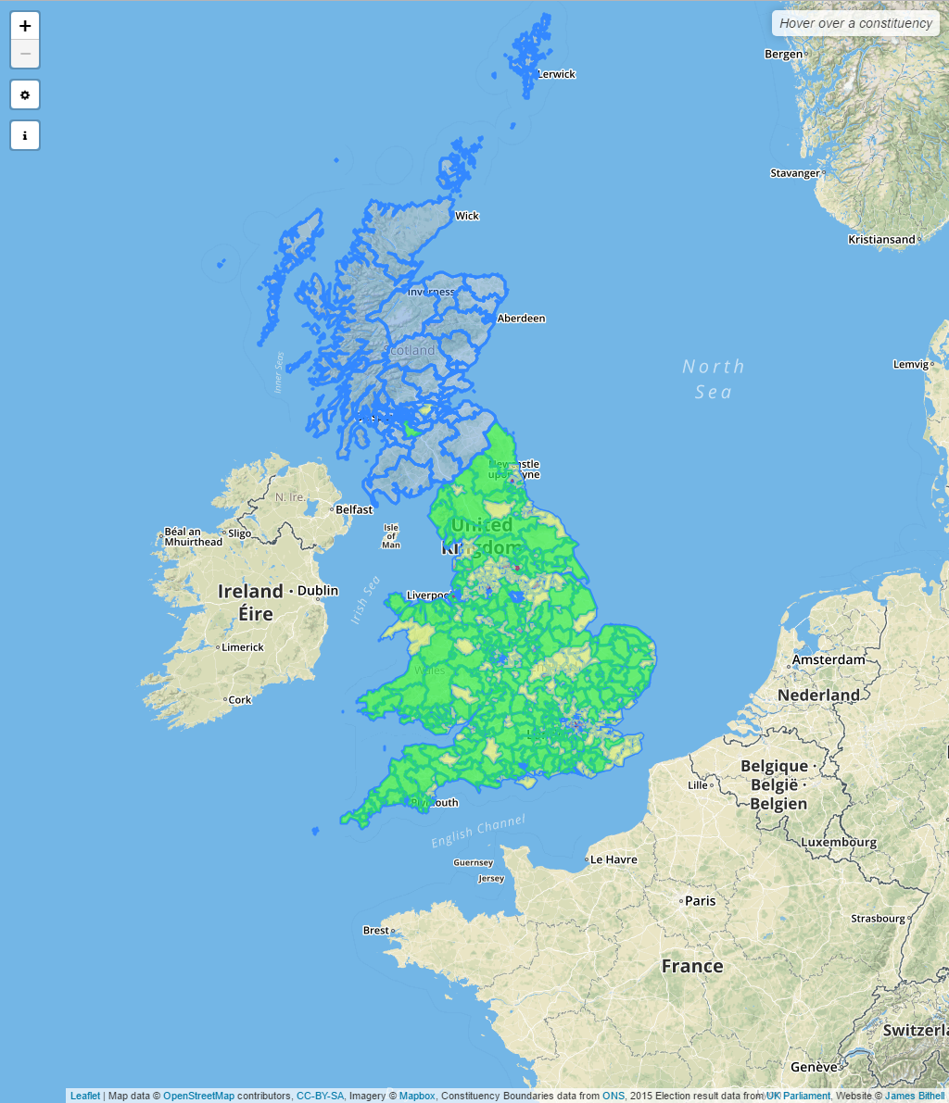

Figure 3 - Crime data for England & Wales by Constituency[2]

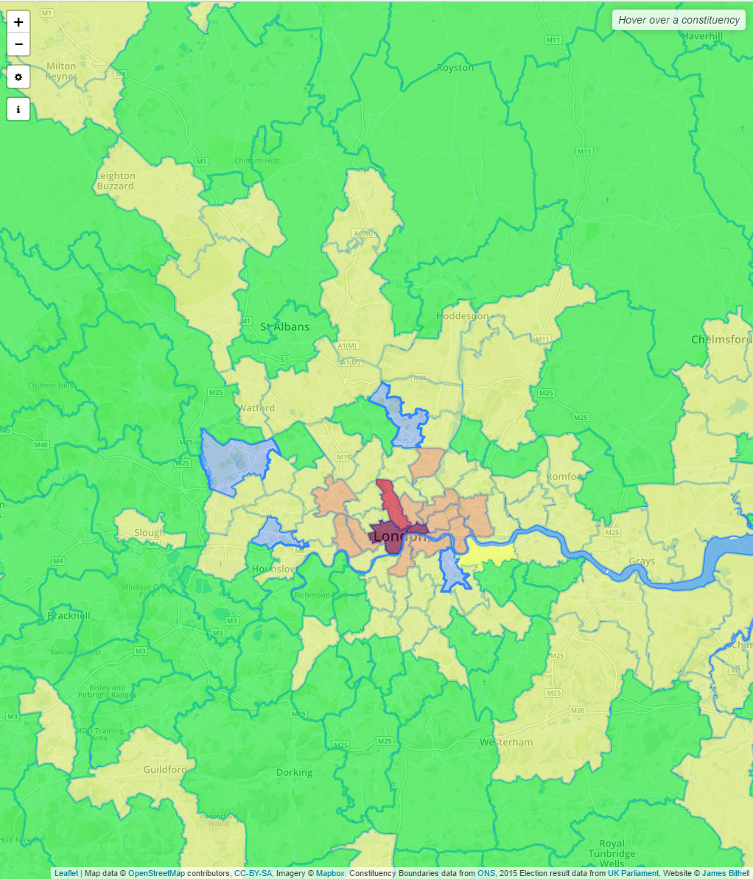

Figure 4 - Crime for London

*The scale is from Green to Yellow to Red with Red being the highest crime.*

This section of map highlights well the challenge of this dataset as the crime in the seat of “the two cities” is far higher because of the higher numbers of arrests for anti-social behaviour and low level pickpocketing.

# Crime Data

Criminality is a key socio-economic indicator because it is an easily accessible and regularly reported dataset that when compared with other regions – so I decided to try and present it

The data is released by the home office for England and Wales on a postcode by postcode basis. From <https://ukcrimestats.com/> I was able to purchase this data adjusted for each individual constituency – and so I started out by exploring the correlation between the projected vote in a poll produced by independent Nigel Marriott and the amount of crime in each constituency.

I should note that I haven’t been able to consider every constituency in this data – with only 551 seats included (81 have been left out) due to issues surrounding availability of crime data for their seat. Policing is a devolved issue in Scotland so crime isn’t reported through the same channels in the way the home office releases data for England and Wales so most of those seats left out were in Scotland.

The “National Average” black line included is a simple mean of the crime rate for the 551 constituencies in each case, though where data has been adjusted it is a mean of the adjusted values, thus it provides hopefully useful context of crime rate.

Figure 5 - Percentage vote prediction for the 2017 General Election against total police reported crimes

Nigel is an independent statistician who had produced this polling on the 4th June, before the actual poll on the 8th June. I preferred his poll because not only was it a poll of polls, but it re-examined their data on a seat by seat basis – so I could get a prediction of what the result was expected to be in 2017 for each seat – where I had crime data. He predicted a conservative majority of 105, which is in line with most predictions at that time.

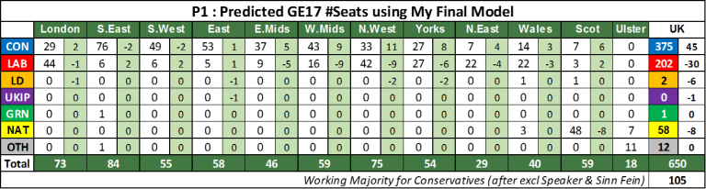

Figure 6 - Nigel Marriott's predictions for the 2017 General Election

As shown in Figure 5, I downloaded the crime data for a full year March 2016 to March 2017 to try and eradicate any seasonal variations in crime rate and provide a fuller picture of the situation in each of the seats before the general election. I then plotted this, raw, against the vote share Nigel was predicting for each constituency. For simplicity – I had only plotted the trendlines, but with the full raw data the picture appears a little more mixed though especially for the conservatives the trend is clear.

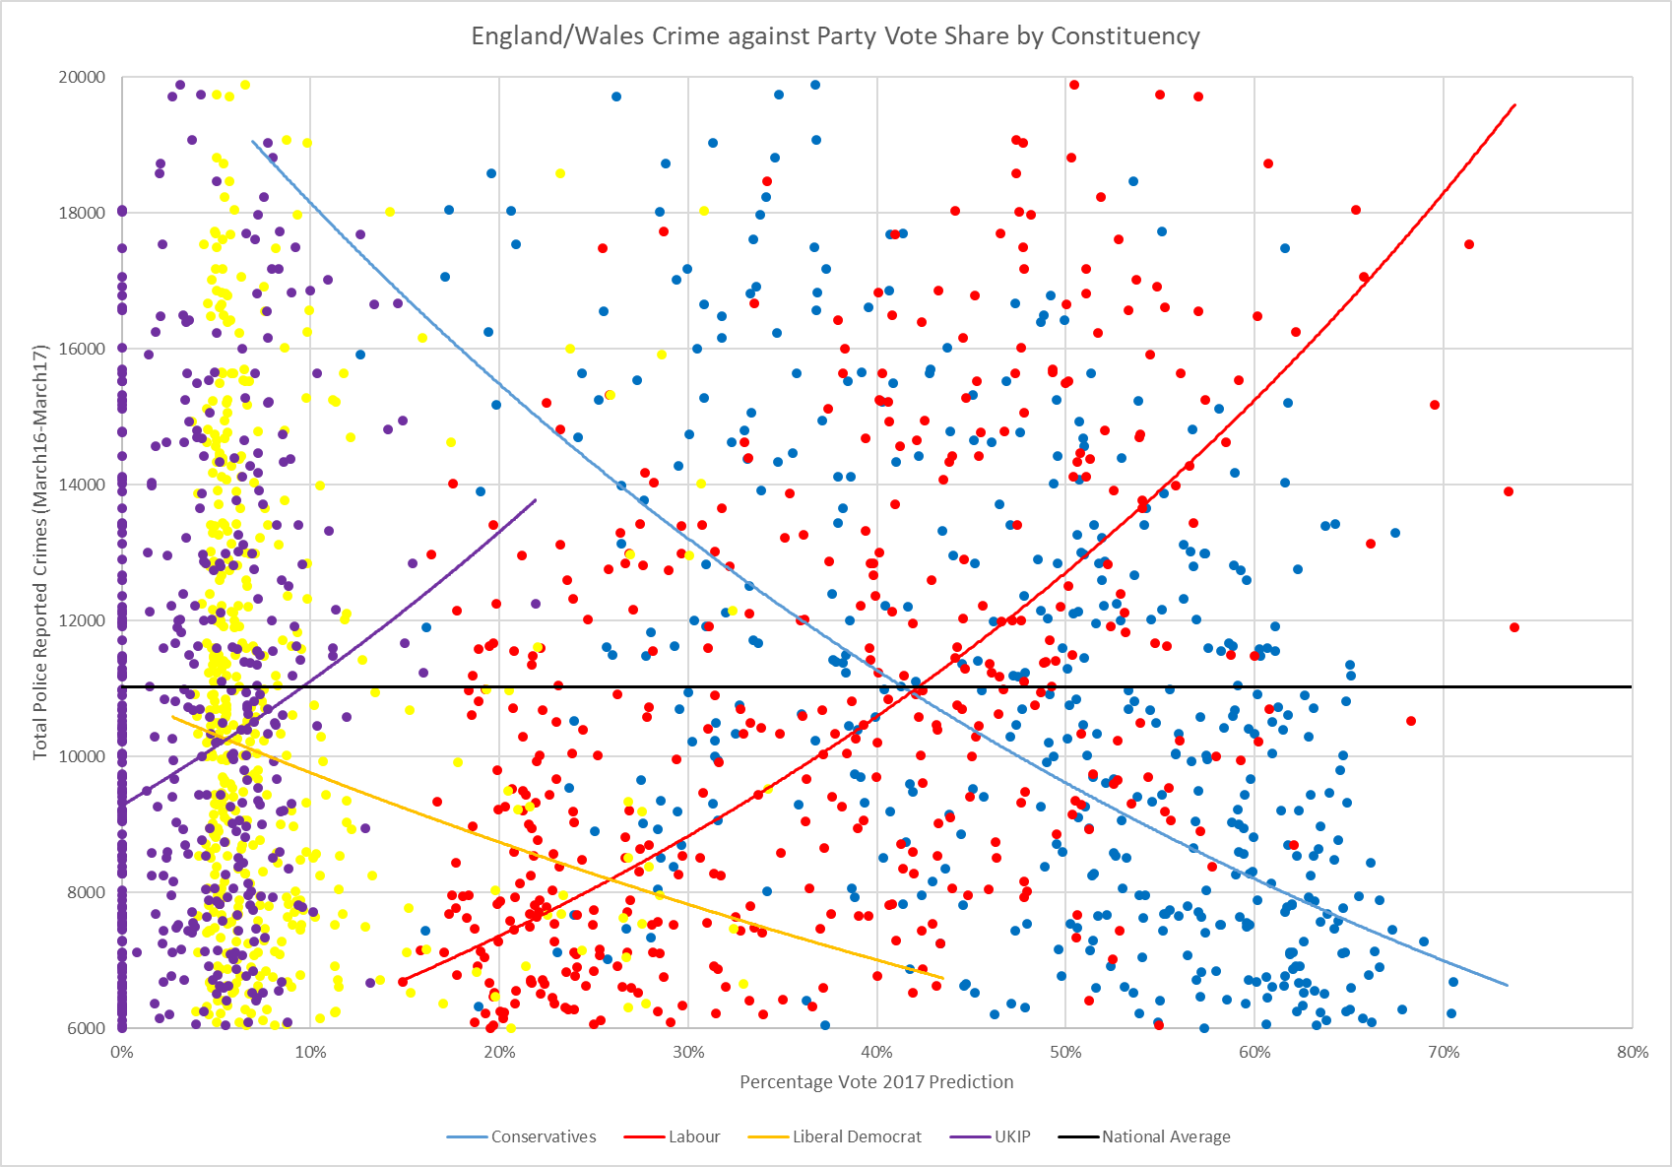

Figure 7 - Full plot of Percentage vote prediction for the 2017 General Election against total police reported crimes[3]

Following on from this I decided to download the actual data for the 2015 general election and plot that instead to see if there would be a similar trend. The results were almost identical – but raised some important questions.

Figure 8 - Percentage vote by party for the 2015 General Election against total police reported crimes

The first thing that struck me was the change in trend for UKIP – which was expecting very different results in 2017 than it had in 2015 before the referendum on our membership of the European Union. It also struck me that Labour has its heartlands in the more populous areas of the country – such as London – where there is a higher population density – which we know to result in a higher crime rate. It therefore made more sense to adjust the crime data for the population density.

I did this by dividing the total number of crimes by the population according to the 2011 census – and much to my surprise (I had expected the statistical fun to end here as the trend was about to be disproved) the trend was just as strong.

Figure 9 - Percentage vote by party for the 2015 General Election against total police reported crimes adjusted for population density

Again, I felt it was important to include the data without trendlines to give an idea of picture, which is presented as Figure 10. For the 2015 results I also included the Green Party, as though they didn’t feature so heavily in the poll there were also an interesting trend to present – being relatively similar to UKIP.

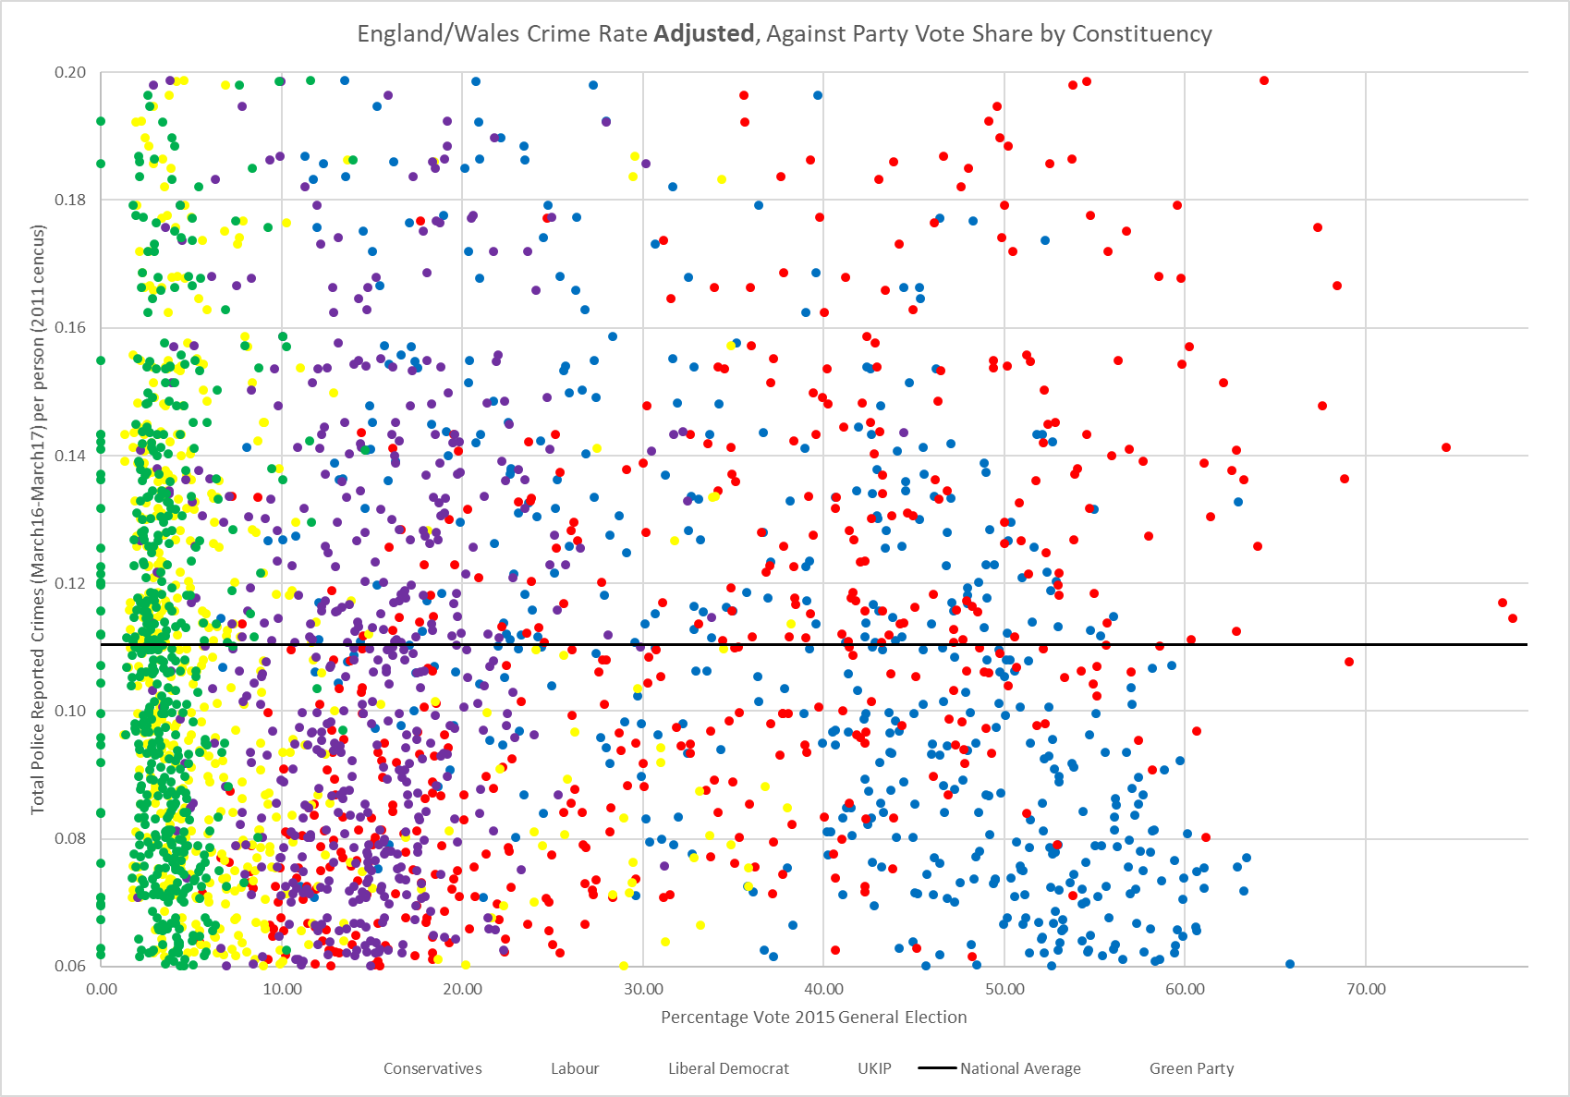

Figure 10 - Percentage vote by party for the 2015 General Election against total police reported crimes adjusted for population density - as full data

At this point I thought it was also interesting to present the population density alone against the crime rate to see how the trend holds out. As Figure 11 shows, there is a strong correlation between Labour voters and high population density. I then considered if it would be more interesting to aggressively adjust the data for population density – so instead of dividing it by the population I might divide the number of crimes by the population density. Thus for an area that has a very low population density (in my data that was Brecon and Radnorshire in South Wales, with a density of 0.23) the number of crimes reported would be quadrupled, but for Westminster North – a labour safe seat with a population density of 146, the number of crimes would be divided by 146. Thus very rural areas would have their crime rate adjusted quite aggressively as would very dense areas – the result is Figure 12.

Figure 11 - England/Wales Population Density Against Party Vote Share by Constituency at the 2015 General Election

Figure 12 - Crime rate adjusted for population density (not just population) against vote share by constituency

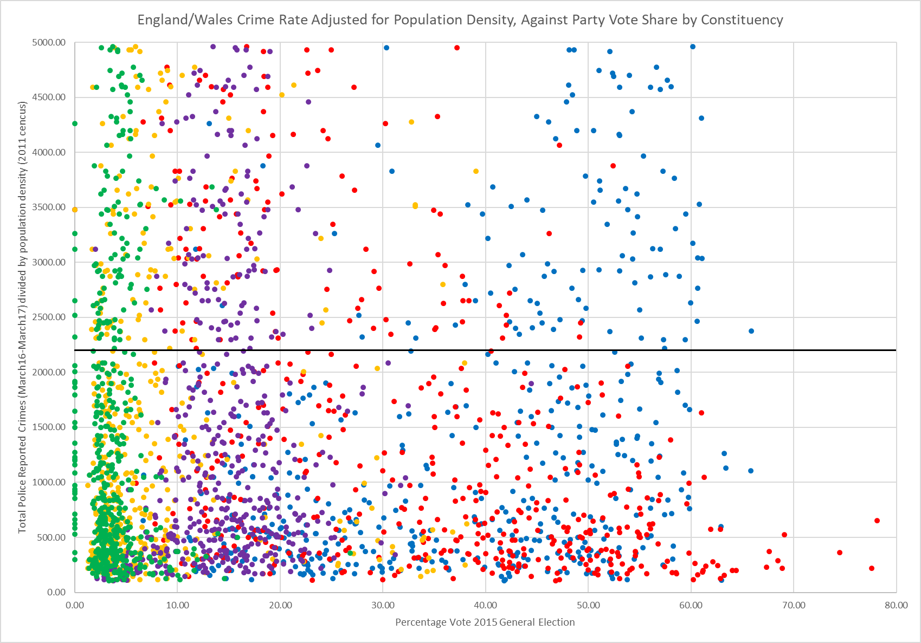

Figure 13 - Crime rate adjusted for population density (not just population) against vote share by constituency (full data)

Figure 12 demonstrates a very interesting relationship that warrants further exploration – the trend is almost a perfect inverse of what we’ve seen before, except for UKIP who seem a bit anomalous. I interpret this as being a function of the figures – whereas populations in each constituency are relatively regular because that’s how their borders are chosen (by populations) there is a huge variation in population density – and therefore by dividing by population density I’m merely skewing the data.

I posted these graphs in a young political group based on Facebook on the 3rd June, and asked people to interpret what they thought of them – to gauge how people may respond to these findings. Figure 14 shows their responses, and I’ve commented on a few.

|  |  |
| --- | --- |
| Figure 14 - Results from Facebook poll | *This user went on to be removed from the group for other comments they made*  *The group has some extreme views on both the left and right*  *This statistical evaluation doesn’t allow for an examination of whether “labour are a cause” because it’s based national polls where crime in an individual area isn’t controlled based on that area’s voting.* |

# Unemployment

Unemployment is a key socioeconomic indicator – it is a key guide to the health of the economy and the current feelings of the population.

Figure 15 - Unemployment against Party Voting

Figure 15 shows much what you might expect – that Labour’s more left wing policies tend to appeal more to those who are unemployed because they mostly support social security funding. The UKIP trend is also as expected – that those who feel the pressure of unemployment might look to blame immigration or Britain’s membership of the European Union for their unemployment. What’s interesting is that the Green Party and Liberal Democrats see almost the opposite trend to the Labour party – which is especially intriguing as they are both considered “centre left” parties – that would perhaps favour the unemployed, although it’s fair to say this is a very metropolitan outlook and for many of those in industrial heartlands I’m sure the idea of protecting the environment appeals – just not as much as the idea of having a job again.

# 2017 General Election update

Midway through this project the 2017 General election took place and though I had included polling in the original crime analysis the polls were really nothing like the actual result, so I thought it was only right that I re-run the original analysis, and thus Figure 16 shows the same graph as Figure 9, just this time with the new results also included. Dashed lines indicate 2015. The same crime & population data was used, and thus the average remains static.

Figure 16 - Crime rate against 2015 & 2017 General Election Result

The data is interesting, and it’s possible to draw almost identical conclusions to the 2015 results, so I’ll only briefly comment on a few differences. Firstly the three largest parties in England and Wales showed identical trends, though with their curves shifted slightly as their proportion of votes overall shifted – this also indicates nicely the idea of a national swing affecting most seats by around 5-10%, when local swings are largely ignored. For UKIP, their voting patterns were made slightly more extreme – with those voting UKIP only the remaining “die hard” anti-Europeans keen to see the departure project finished, thus the shift in the curve is a bit like the shift in elasticity of a supply curve as it gets steeper. The fact it reaches 0 on the X axis also nicely demonstrates the fact the UKIP chose not to field candidates in every seat this time, as they didn’t wish to oppose Conservative candidates who campaigned to leave the EU. Finally the Green Party, their trend was a complete shift mostly as they saw and overall lower vote share in most seats, but also as those areas in which they received more votes in higher crime areas in 2015 (such as Bristol west) saw a huge reduction in vote share (a fall of 13.9 percentage points), but they made huge gains of 10.5 percentage points in Brighton, which has a pretty low crime rate.

# Conclusion

This project, which has slightly changed course during its duration (having started as a mapping project and ended as a graphing exercise), aimed to explore the correlation between a few socio-economic indicators and how people vote. I believe it’s achieved that by demonstrating the correlation between how people vote and unemployment in their area, and crime in their area. I aimed to remain as objective as possible by not exploring the policies of each of the parties and the impact that they may have, and left that open to both you as a reader, but also the Facebook poll of young political enthusiasts shown in Figure 14 for you to draw your own conclusions.

I finish with Figure 17 which shows the percentage of the population who are UK born against the percentage vote share UKIP received at the 2015 and 2017 General Elections – showing a surprising difference between the two elections. In 2017 there was a clear trend that there is a larger vote for UKIP in areas with a smaller percentage of UK born individuals (I was also able to find an even stronger correlation for those who are not white British) but in 2015 this trend was almost the opposite (and similar again for those who are not white British). The reason I have chosen to conclude with this is that is shows that the graph can’t tell the whole story – the likelihood is that the same people are voting for this party in the same elections – but we can’t really tell what impact the demographic has upon how people vote for a certain party because there is no demographic data available on how individuals themselves actually vote due to the private nature of British voting - the data here sadly can’t tell us the full picture.

Figure 17 Percentage of Population who Are UK Born against UKIP Vote Share at General Elections

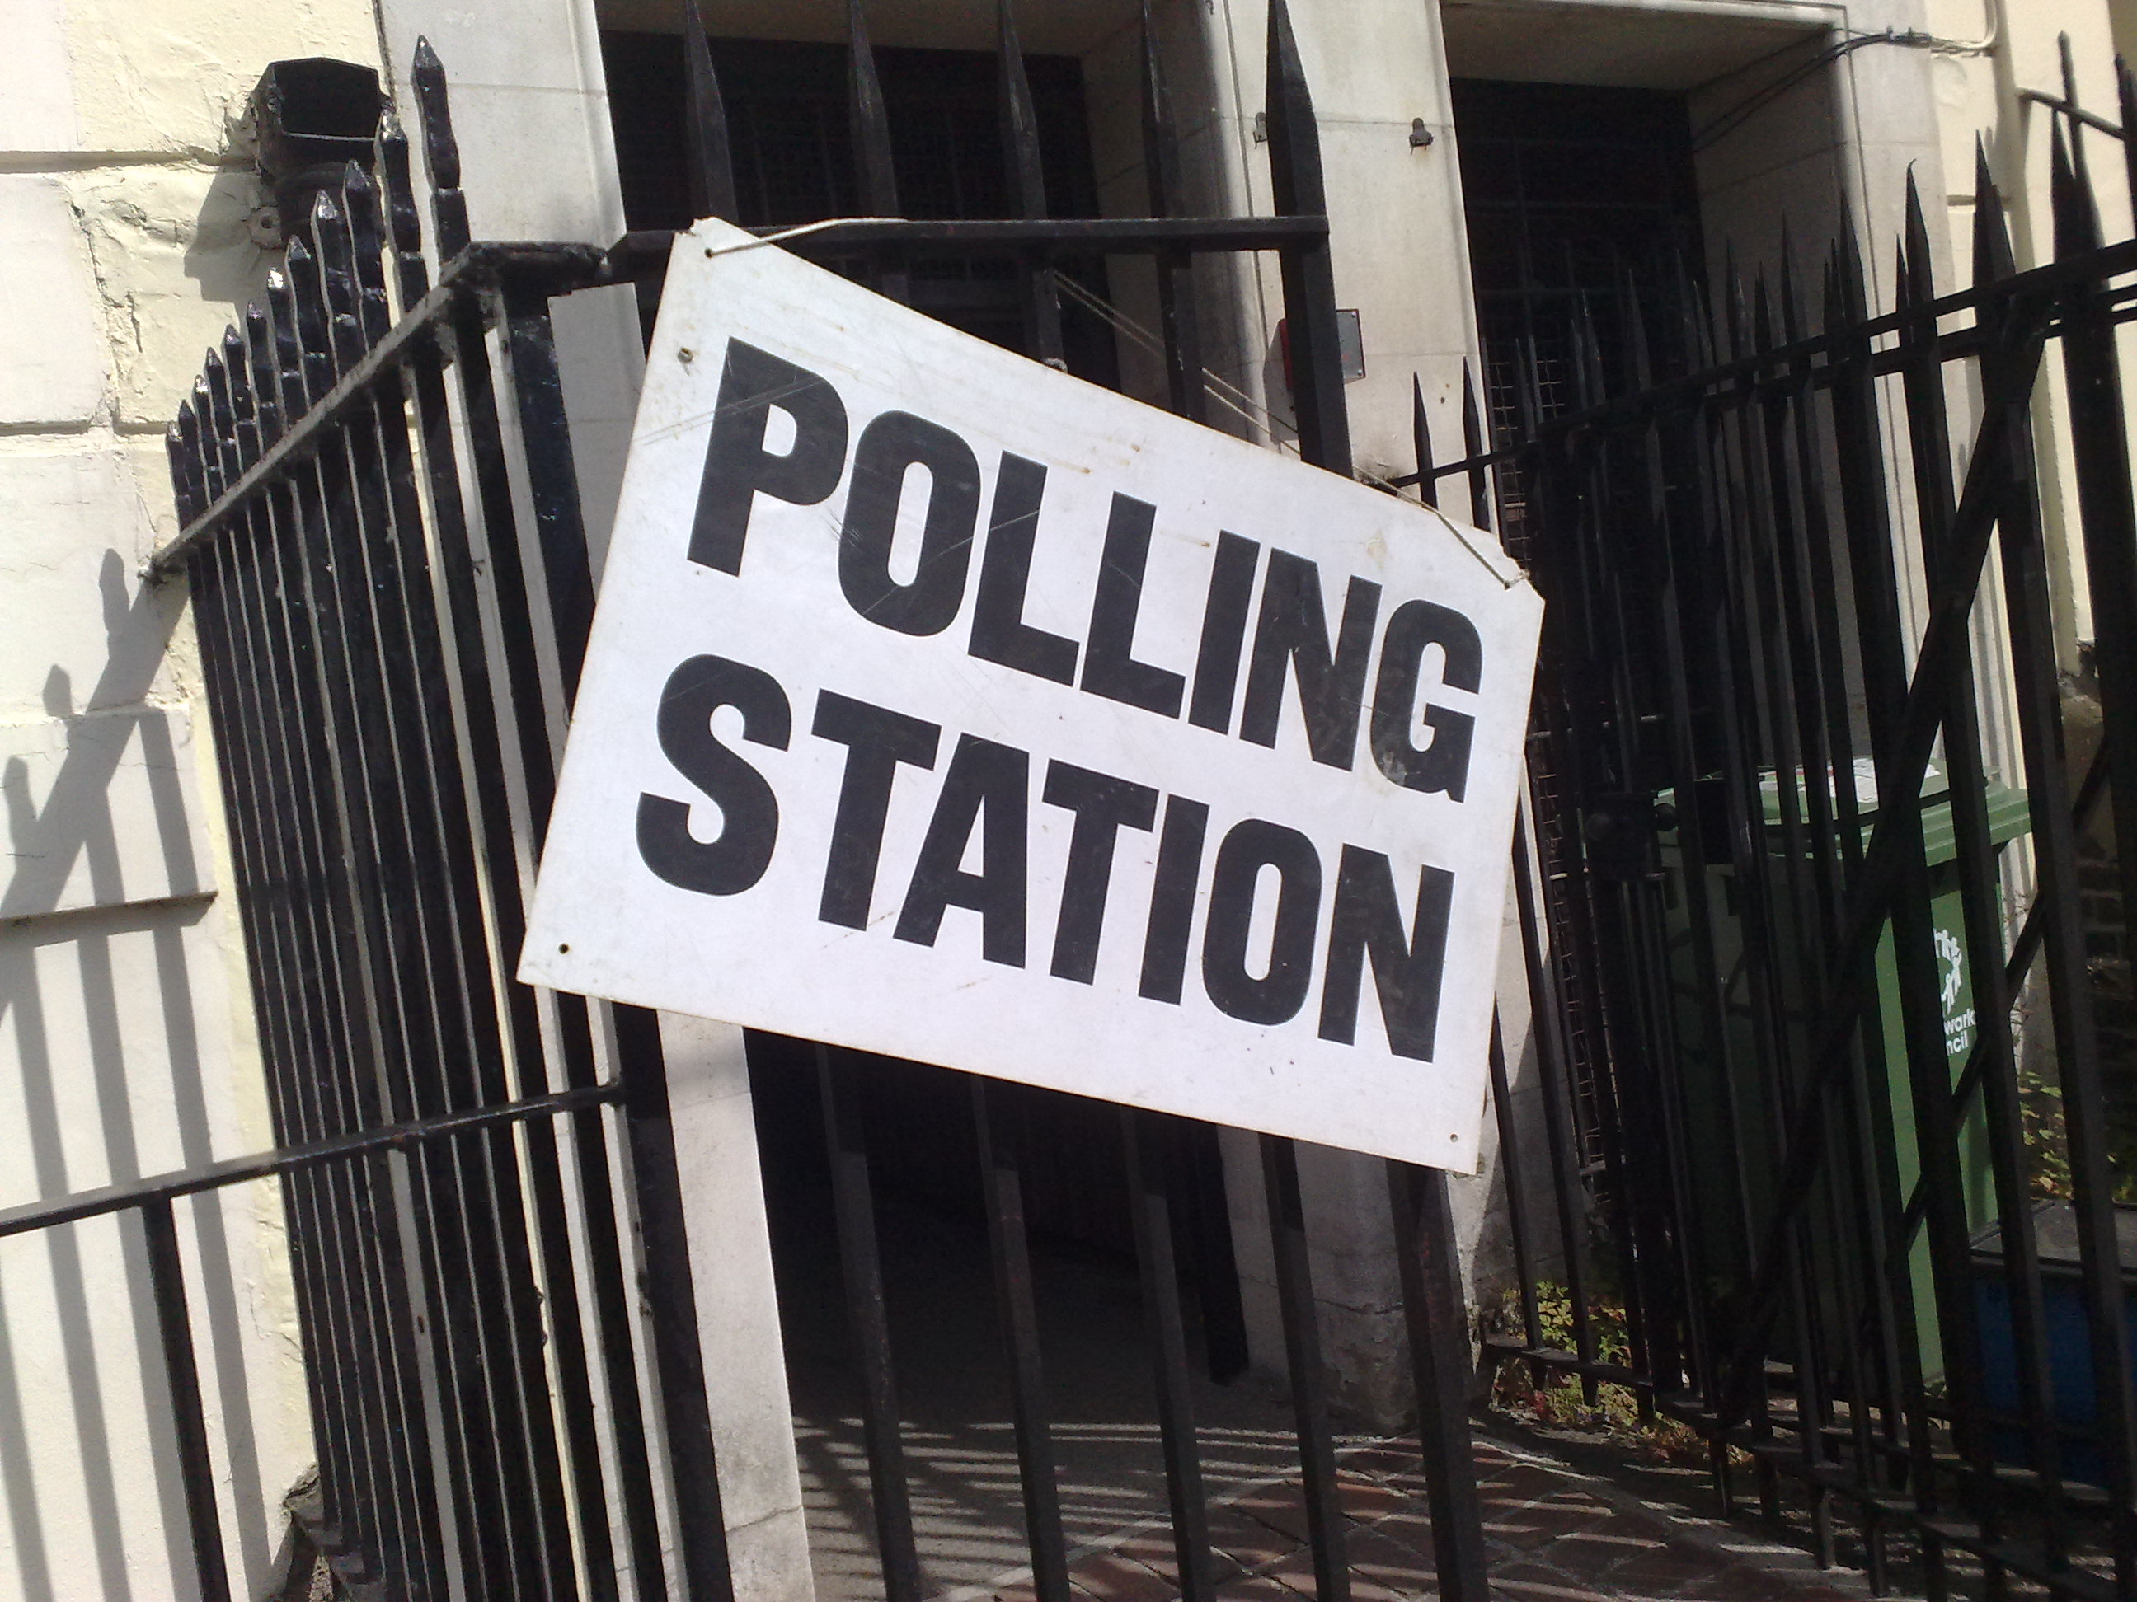

1. The white seat is the speaker of the House of Commons, who is *officially* independent
2. We often don’t have data because it’s not included for Scotland and some seats due to police policies
3. The outliers have been removed from this graph to present it better